Name:___________

Database Design –Assignment 2

Remember: double quotes for all character and date attributes,   
All names should be in mixed case with no spaces

NO COPYING! Help each other but do your own work. Otherwise you will be given an "F" for the class.

This assignment uses a book store database.

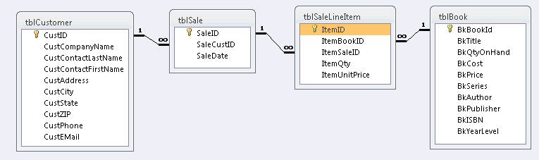

It is an example of the structure of databases that contain retail sales data. I call it the Sale model and it will be the focus of the exams.

If you have SQL Server installed on your personal computer, see [Export Access Tables To SQL Video](http://business2.ecu.edu/users/bradleyj/dbclass/ExportAccessTablesToSQL/ExportAccessTablesToSQL.html) in the How to… area of Bb for instructions. This video moves data from Access to a SQL Server named PS5342\SQLEXPRESS. This is the SQL Server on my local machine, PS5342. The name of your SQL Server should show on the SQL Server login screen. Open the attached Access database and export the four tables into SQL Server. For this assignment you will need all four tables. These tables have been provided for you on the seesaw.intra.ecu.edu server which is accessible in VCL. See the How to Use the Virtual Computing Lab and SQL in the How to… area of Bb.

We would like to know which customers are buying which books. This requires data from two tables, tblCustomer and tblBook. SQL can only output data from one table so we must join the input tables together to create a single temporary table before we can select data for output. Joining tables requires telling SQL that the Primary Key (PK) of one table must always equal the Foreign Key (FK) in the other table.   
As you can see, tblCustomer can only be joined to tblSale. Therefore, to gather information about which book titles customers are buying, we must join tblCustomer to tblSale then tblSale to tblSaleLineItem then tblSaleLineItem to tblBook. This is accomplished using three special Where statements we will call Join Conditions.  
Your text book uses the exact same name for the PK and FK attributes to show you that these contain the same data. The disadvantage to this naming convention is that you must add the name of the table to the field name in the SQL code (for example, tblBook.CustID). Proper naming convention requires each field to have a unique name. This is often accomplished by adding a table prefix to each field (for example, Cust + field name). With unique names, using the table name is not necessary (except for recursive relationships). So a join condition would be:   
Where PK = FK or Where CustID = SaleCustID  
  
If the answer is a list of items, the list should be sorted so there can be no randomness in the sort order. Always use meaningful column headings.  **Samples of code you need can be found in How to … in Bb in SQL Code Samples and in chapters 3 thru 5 of the text book.**

**After testing your code in SQL Server to make sure it works, copy/paste it from SQL Server into this Word document. Name this document *yourlastname.doc* Be sure to put your name in this document. Submit this document containing all SQL code to the Assignment 2 Submission link prior to the due date/time.**

Always execute these four commands first to set the option to use double-quotes instead of single-quotes.

Set ansi_nulls on

Go

Set quoted_identifier off

Go

1. List Customer contacts where the customer ID is between 5 and 20. Only list ID, name (combined into Last, First as one column e.g. Smith, John), and city and state (combined into one column e.g. Greenville, NC). Sort by customer ID. Highlight the results by right-clicking in the results table and clicking on Select All. Then press ctrl-c and paste the results below immediately following your SQL code.   
  
SELECT CustID, CustContactLastName + ", " + CustContactFirstName AS "Customer Name", CustCity + ", " + CustState AS "Location"

FROM tblCustomer

WHERE CustID <= 20 AND CustID >= 5

ORDER BY CustID

2. How many Customers live in Virginia?   
SELECT COUNT(*) AS "# of Virgina Customers"

FROM tblCustomer

WHERE CustState = "VA"

3. What is the average number of books (ItemQty) for sales from each state in tblCustomer?

(use Group By to list the state and the average) (Review the Sale model in Chapter 5)

SELECT AVG(ItemQty) AS "Average Books per Sale", CustState AS "State"

FROM tblSaleLineItem, tblCustomer

GROUP BY CustState

4. What is the lowest price we charged for a book last year?

In the Criteria, calculate last year as this year -1 (see Sample SQL Code in How to ...).  
SELECT MIN(ItemUnitPrice)AS "Lowest Priced Book Sold Last Year"

FROM tblSaleLineItem, tblSale

WHERE Year(SaleDate) = Year(DateAdd(Year,-1,GetDate()))

5. List the titles and prices (BkPrice) of the books whose price is greater than the average price (ItemUnitPrice)

of all books sold this year (use the current date function). Remove duplicates by using Select Distinct BkTitle ...  
SELECT DISTINCT BkTitle, BkPrice

FROM tblBook

WHERE BkPrice >

(SELECT AVG(ItemUnitPrice)

FROM tblSaleLineItem, tblSale

WHERE YEAR(SaleDate) = YEAR(GETDATE()))

6. List the sale year, companies, their city and state (combined), and the total amount of sales (quantity times price) for each sale year in tblSale.

SELECT SUM(ItemQty * ItemUnitPrice) AS "Total Sales for Year", YEAR(SaleDate)AS "Year", CustCompanyName, CustCity + ", " + CustState AS "Location"

FROM tblSaleLineItem, tblSale, tblCustomer

GROUP BY CustCompanyName, YEAR(SaleDate), CustCity, CustState

ORDER BY YEAR(SaleDate), CustCompanyName